 | CAMP CARPENTER  CUB WORLD RESIDENT CAMP 2011 | 
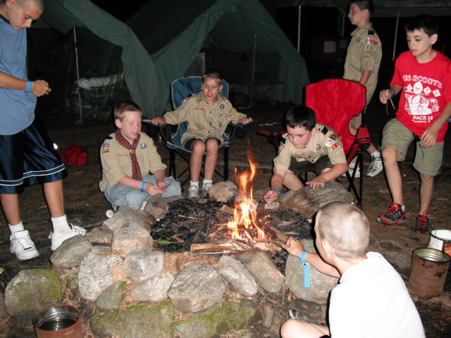
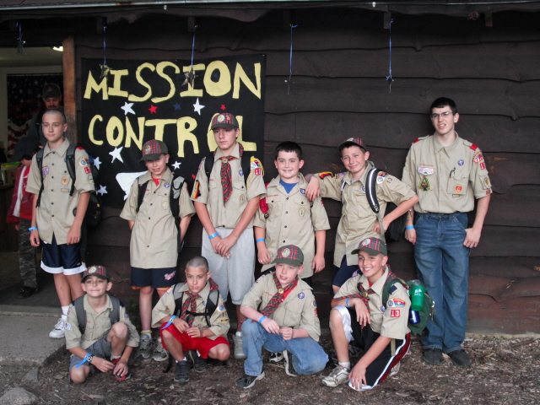

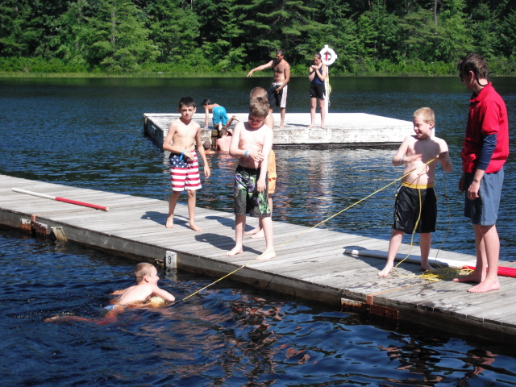
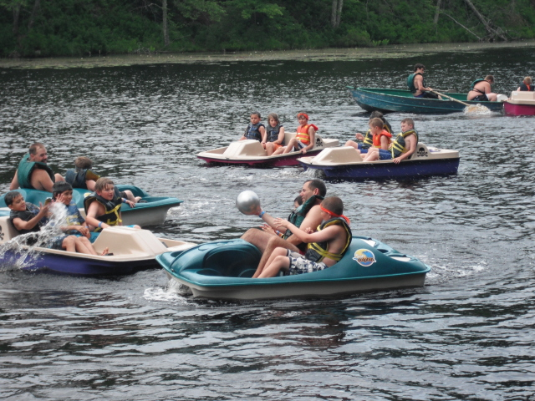
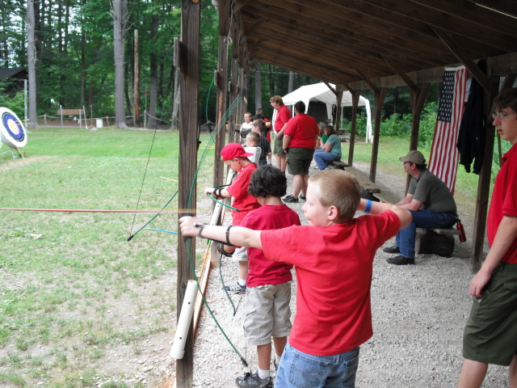
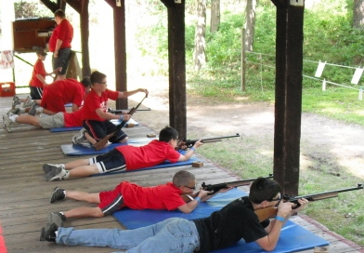
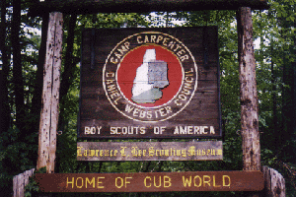

Pack 13, Mansfield, MA
July 10-14 - Week 3 - Piscataqua Camp Site

A week with Pack 13 at Cub Scout Summer Camp is truly one of the greatest experiences your son will have during the long summer months! Each and every Cub Scout (& parent) that has ever attended Summer Camp always come home with lots of smiles, lots of stories, lots of memories, and lots of experiences. This summer Pack 13 will return to Camp Carpenter – Cub World, located in Manchester, NH.
Camp Carpenter is a nationally recognized resident camp, that has been serving Cubs for over 60 years. It is situated on a beautifully wooded area right outside Manchester, NH. The facilities include a modern dining hall (& the food is excellent!), platform tents and all the activities areas you would expect from a top-notch scout camp. All you need for this week are a daypack, a sleeping bag and a couple of other easy-to-find items. The Camp Staff really makes the camp fun for the kids, and they are some of the best around!
Your son will have the opportunity to take part in Games, Handicrafts, Sports, Nature, Hikes, Archery, BB guns, Swimming, Fishing, Boating and so much more! The theme areas at Cub World Resident Camp consist of a full scale Fort, a Native American Village, Webelos Woods Adventure Area & Pirates Cove. At each of these areas, campers participate in both learning & fun activities. At Camp, Cubs & Webelos have an opportunity to work on achievements, electives & activity badges. We can not express to you how much fun your son will have for such a small expense.
We understand that many parents cannot take a full week off to spend with their sons. There are many options. First, please don’t be afraid to send your son alone. We’ve had many boys who have gone “solo”, and every last one has had a blast. The pack leaders & camp staff all have experience with handling homesickness, and any other issues that boys (even ones with their parents) might exhibit. Also, BSA’s youth protection policies are, as always, enforced, so no boy will be without proper supervision at any time. Alternatively, adults may come for a partial week, or even “switch off” parents to make it a full week. We can be as flexible as you need. We just want to see your son have the time of his life!
NO CAMPER OR LEADER WILL BE ALLOWED TO STAY IN CAMP WITHOUT A COMPLETED MEDICAL FORM (Parts A, B & C) SIGNED BY A DOCTOR! Book your physicals now!
All completed medical forms for Pack 13 are due at least two weeks prior to start of the registered session (June 27, 2011)

Cub World  Resident Camp | $50 deposit paid by March 15; balance paid by May 17 | $50 deposit paid after March 15;balance paid by May 17 | Payments after May 17
 | $280** | $290** | $305**
* includes cost for camp, a group photo and “pack out night” munchies.
** Prices reflect 2010 rates. 2011 are not yet released, and are subject to change.
Deposit Deadline March 13
Contact Rusty Whittaker (h) 508-339-0822, e-mail rustywhitaker@aol.com for more information.
Visit www.dwcbsa.org for all the information and registration forms needed for camp.

